PPSUC Lab Internal Programs & Solutions

# K. V. R. Karthik

# CSD Semester II

# 323103383035

**Program1: Program to check if the given number is Armstrong or notusing for loop.**

**Solution:**

#include<stdio.h>

#include<math.h>

void main()

{

int n,rem=0,i,sum=0,digits=0;

printf("Enter your number: ");

scanf("%d",&n);

int temp = n;

for(i=1;temp>0;i++)

{

temp = temp/10;

digits++;

}

temp = n;

for(i=1;n>0;i++)

{

rem = n % 10;

sum = sum + (pow(rem,digits));

n = n/10;

}

if(temp==sum)

printf("%d is an Armstrong number\n",temp);

else

printf("%d is not an Armstrong number\n",temp);

}

**Output test cases:**

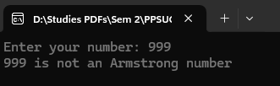

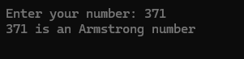

**Program2: Program to print all the odd numbers within the given range and find sum and average of those odd numbers.**

**Solution:**

#include<stdio.h>

void main()

{

int a,b,i,sum=0,count=0,avg=0;

printf("Enter two numbers: ");

scanf("%d %d",&a,&b);

if(a<b)

{

for(i=a;i<=b;i++)

{

if(i%2!=0)

{

printf("%d ",i);

sum+=i;

count++;

}

}

avg=sum/count;

printf("\nThe sum of these odd numbers is %d and their average is %d\n",sum,avg);

}

else

printf("Invalid range\n");

}

**Output test cases:**

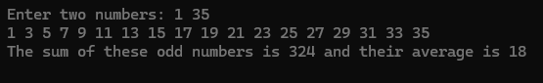

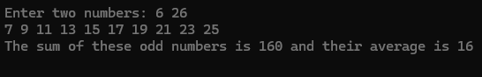

**Program3: Write a C program to find out area and perimeter of a rectangle. Use two functions.  
void area(int length, int breadth);  
int perimeter(int length, int breadth);  
(NOTE: perimeter function should return the value to main program)**

**Solution:**

#include<stdio.h>

void main()

{

void area(int ,int );

int perimeter(int ,int );

int a,b,peri,area_value;

printf("Enter length and breadth of rectangle: ");

scanf("%d %d",&a,&b);

area(a,b);

peri=perimeter(a,b);

printf("The perimeter of the given rectangle is %d\n",peri);

}

void area(int length, int breadth)

{

int area = length*breadth;

printf("The area of the rectangle is %d\n",area);

}

int perimeter(int length, int breadth)

{

int perimeter = 2*(length+breadth);

return perimeter}

**Output test cases:**

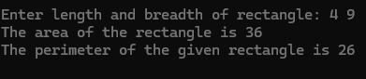

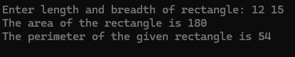

**Program4: Program to find factorial of a number using functions**

**Solution:**

#include<stdio.h>

void main(){

int factorial(int);

int n,i,res;

printf("Enter your number: ");

scanf("%d",&n);

res = factorial(n);

printf("The factorial of %d is %d",n,res);

}

int factorial(int n){

int i,fact=1;

for(i=1;i<=n;i++)

fact = fact*i;

return fact;

}

**Output test cases:**





**Program5: Program to print LCM of two numbers**

**Solution:**

#include<stdio.h>

void main()

{

int n,m,lcm,max,c;

printf("Enter two Numbers : ");

scanf("%d %d",&n,&m);

if(n>m)

max=c=n;

else

max=c=m;

while(1)

{

if(max%n==0 && max%m==0)

{

lcm = max;

break;

}

max = c++;}

printf("L.C.M of %d and %d is %d",n,m,lcm);

}

**Output test cases:**





**Program6: Program to print Fibonacci series of n numbers using do-while loop (where n is input taken from user)**

**Solution:**

#include<stdio.h>

void main()

{

int n,a=0,b=1,c,i=2;

printf("Enter number of terms in Fibonacci series: ");

scanf("%d",&n);

printf("%d %d ",a,b);

do

{

c=a+b;

printf("%d ",c);

a = b;

b = c;

i++;

}while(i<n);

printf("\n");

}

**Output test cases:**

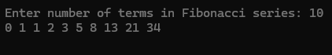



**Program7: Program to reverse the digits of a given number**

**Solution:**

#include<stdio.h>

int i,rev=0,rem=0;

void main()

{

void reverse(int);

int n,i;

printf("Enter your number: ");

scanf("%d",&n);

reverse(n);

}

void reverse(int n)

{

for(i=1;n>0;i++)

{

rem = n%10;

rev = rev*10 + rem;

n/=10;

}

printf("Result after reversing the digits is %d",rev);

}

**Output test cases:  
**



**Program8: Program to perform temperature conversions from Fahrenheit to Celsius and vice versa**

**Solution:**

#include<stdio.h>

float cel,fah;

void main()

{

void cel_fah(float);

void fah_cel(float);

int choice;

float result;

printf("Choose your conversion\n1. Celsius to Fahrenheit\n2. Fahrenheit to Celsius\n");

scanf("%d",&choice);

switch(choice)

{

case 1:

printf("Enter tempaerature reading: ");

scanf("%f",&cel);

cel_fah(cel);

break;

case 2:

printf("Enter temperature reading: ");

scanf("%f",&fah);

fah_cel(fah);

break;

default:

printf("Invalid choice\n");

}

}

void cel_fah(float cel)

{

float fah;

fah = 32 + ((9*cel)/5);

printf("Result is %.2f Fahrenheit\n",fah);

}

void fah_cel(float fah)

{

float cel;

cel = (5*(fah-32))/9;

printf("Result is %.2f Celsius\n",cel);

}

**Output tests cases:**

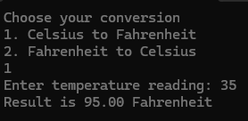 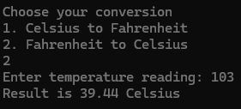

**Program9: Program to swap two values without using a third variable(usingpass by value method)**

**Solution:**

#include<stdio.h>

int temp=0;

void main()

{

void swap(int , int );

int a,b;

printf("Enter two numbers: ");

scanf("%d %d",&a,&b);

swap(a,b);

}

void swap(int a, int b)

{

b = a + b;

a = b - a;

b = b - a;

printf("Result after swapping numbers is %d %d\n",a,b);

}

**Output test cases:**



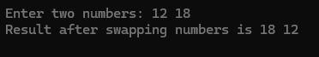

**Program10: Write a C program to check whether the given number is prime or not. (Use a function, where the function returns 1 if it is a prime number, otherwise function returns value 0)**

**Solution:**

#include<stdio.h>

void main()

{

int prime(int);

int n;

printf("Enter your number: ");

scanf("%d",&n);

if(prime(n)==1)

printf("%d is a prime number\n",n);

else

printf("%d is not a prime number\n",n);

}

int prime(int n)

{

int count=0,i;

for(i=1;i<=n;i++)

{

if(n%i==0)

count++;

}

if(count==2)

return 1;

else

return 0;

}

**Output test cases:**

** **

**Program11: Write a C program to print the following pattern**

**1**

**1 2**

**1 2 3**

**1 2 3 4**

**Solution:**

#include<stdio.h>

void main()

{

int n,i,j;

printf("Enter your number: ");

scanf("%d",&n);

for(i=1;i<=n;i++)

{

for(j=1;j<=i;j++)

printf("%d ",j);

printf("\n");

}

}

**Output test cases:**

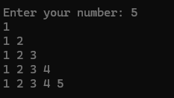 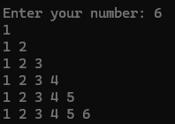

**Program12: Program to extract last two digits of a number, where the number is greater than 2.**

**Solution:**

#include<stdio.h>

void main(){

int n,i,res=0;

printf("Enter your number: ");

scanf("%d",&n);

if(n<100)

printf("Input should be greater than 99\n");

else{

res = n%100;

printf("Last two digits of %d is %02d\n",n,res);}

}

**Output test cases:**

** **

**Program13: Program to print GCD of two numbers**

**Solution:**

#include<stdio.h>

void main()

{

int a,b,min,gcd,i;

printf("Enter two numbers: ");

scanf("%d %d",&b,&a);

if(b<a)

min = b;

else

min = a;

for(i=1;i<=min;i++)

{

if(b%i==0 && a%i==0)

{

gcd = i;

}

}

printf("G.C.D of %d and %d is %d",b,a,gcd);

}

**Output test cases:**





**Program14: Write a C program to print the following pattern  
1 1**

**1 1 1 1**

**1 1 1 1 1 1**

**1 1 1 1 1 1 1 1**

**Solution:**

#include<stdio.h>

void main(){

int n,i,j;

printf("Enter your number: ");

scanf("%d",&n);

for(i=1;i<=n;i++){

for(j=1;j<=2*i;j++){

printf("1 ");

}

printf("\n");

}

}

**Output test cases:  
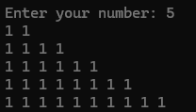 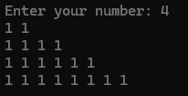**

**Program15: Program to display greatest and smallest of three numbers using a conditional operator**

**Solution:**

#include<stdio.h>

void main()

{

int a,b,c,max=0,min=0;

printf("Enter three numbers: ");

scanf("%d %d %d",&a,&b,&c);

max = (a>b)?(a>c ? a:c):(b>c ? b:c);

min = (a<b)?(a<c ? a:c):(b<c ? b:c);

printf("The greatest of three numbers %d %d %d is %d and the smallest is %d\n",a,b,c,max,min);

}

**Output test cases:  
**



**Program16: Program to print all the Armstrong numbers between 1 and 999**

**Solution:**

#include<stdio.h>

#include<math.h>

void main()

{

int num,r,sum,temp,a=1,b=999,digit=0;

printf("Armstrong numbers from 1 to 999 are \n");

for(num=a;num<=b;num++){

temp=num;

sum=0;

while(temp>0){

r=temp%10;

digit++;

temp/=10;

}

temp=num;

while(temp!=0){

r=temp%10;

sum=sum+pow(r,digit);

temp=temp/10;

}

if(sum==num)

printf("%d ", num);

digit=0;

sum=0;

}

printf("\n");

}

**Output test cases:**



**Program17: Program to print all the even numbers between given range and find their sum and average of all those even numbers**

**Solution:**

#include<stdio.h>

void main()

{

int a,b,i,sum=0,count=0;

int avg = 0;

printf("Enter two numbers: ");

scanf("%d %d",&a,&b);

if(a<b)

{

printf("The even numbers between %d and %d are ",a,b);

for(i=a;i<=b;i++)

{

if(i%2==0)

{

printf("%d ",i);

sum+=i;

count++;

}

}

avg = sum/count;

printf("\nThe sum of all the even numbers is %d and their average is %d",sum,avg);

}

else

printf("Invalid input\n");

}

**Output test cases:**

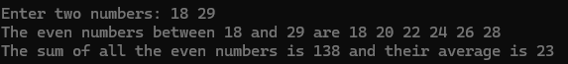

**Program18: Write a C program to print factorial values of all the numbers from 1 to n.  
Take n value from user. Use function for factorial finding. Print as below**

**Factorial of 1 = xxx**

**Factorial of 2 = yyy**

**Factorial of n = zzz.**

**Solution:**

#include<stdio.h>

int main(){

int n;

void fact_1ton(int);

printf("Enter n value: ");

scanf("%d",&n);

fact_1ton(n);

return 0;

}

void fact_1ton(int n){

int fact = 1;

int i = 1;

for(i=1;i<=n;i++){

fact = fact * i;

printf("Factorial of %d = %d\n",i,fact);

}

}

**Output test cases:**

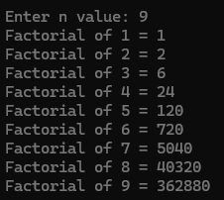 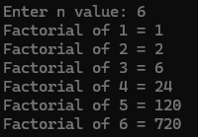

**Program19: Program to display greatest of three numbers using a conditional operator**

**Solution:**

#include<stdio.h>

void main()

{

int a,b,c,max=0,min=0;

printf("Enter three numbers: ");

scanf("%d %d %d",&a,&b,&c);

max = (a>b)?(a>c ? a:c):(b>c ? b:c);

printf("The greatest of three numbers %d %d %d is %d\n",a,b,c,max);

}

**Output test cases:**





**Program20: Write a C program to find out grade of a particular student based on his (Maths, Physics and Chemistry) marks. Calculate TOTAL, AVERAGE, GRADE(using if-else ladder).**

**Solution:**

#include<stdio.h>

void main()

{

int m,p,c,total,avg;

printf("Enter marks for the following subjects\nMaths: ");

scanf("%d",&m);

printf("Physics: ");

scanf("%d",&p);

printf("Chemistry: ");

scanf("%d",&c);

total = m+p+c;

avg = (int)total/3;

printf("Average is %d\n",avg);

if(avg>=90 && avg<=100)

printf("Your grade: A\n");

else if(avg>=80 && avg<90)

printf("Your grade: B\n");

else if(avg>=70 && avg<80)

printf("Your grade: C\n");

else if(avg>=60 && avg<70)

printf("Your grade: D\n");

else

printf("Your grade: F\n");

}

**Output test cases:**

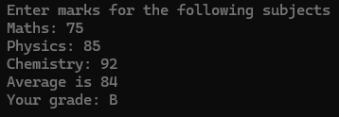

**Program21: Program to calculate simple interest from given input values**

**Solution:**

#include<stdio.h>

void main(){

int p,t,r,SI;

printf("Enter principle: ");

scanf("%d", &p);

printf("Enter time period: ");

scanf("%d", &t);

printf("Enter Rate of interest: ");

scanf("%d", &r);

SI=p*t*r / 100;

printf("Simple Interest is %d", SI);

}

**Output test cases:**

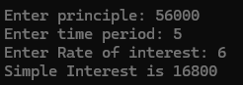

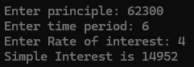

**Program22: Write a C program to print the following pattern**

**#**

**# #**

**# # #**

**# # # #**

**Solution:**

#include<stdio.h>

void main(){

int n,i,j;

printf("Enter your number: ");

scanf("%d",&n);

for(i=1;i<=n;i++){

for(j=1;j<=i;j++)

printf("# ");

printf("\n");}}

**Output test cases:**

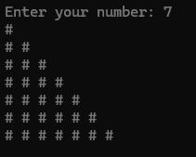 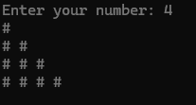

**Program23: Program to display all the prime numbers between the given range of input values**

**Solution:**

#include<stdio.h>

int main()

{

int num,i,counter,a,b;

printf("Enter two numbers(a<b): ");

scanf("%d %d",&a,&b);

printf("The prime numbers between %d and %d are ", a,b);

for(num=a;num<=b;num++)

{

counter=0;

for(i=2;i<=num/2;i++)

{

if(num%i==0)

{

counter++;

break;

}

}

if(counter==0&&num!=1)

printf("%d ", num);

}

printf("\n");

return 0;

}

**Output test cases:**





**Program24: Write a C program to generate a multiplication table upto 20 values, for a given n value.  
n * 1 = n**

**n * 2 = 2n  
.**

**.**

**.**

**n * 20 = 20n**

**Solution:**

#include<stdio.h>

void main()

{

int n,i;

printf("Enter n value: ");

scanf("%d",&n);

for(i=1;i<=20;i++)

{

printf("%d * %d = %d\n",n,i,n*i);

}

}

**Output test cases:**

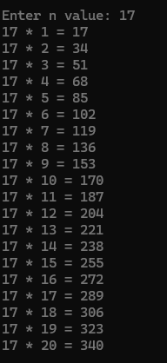 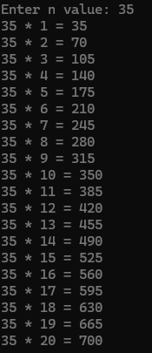

**Program25: Program to check whether the given input character is vowel or consonant**

**Solution:**#include<stdio.h>

void main()

{

char ch;

printf("Enter your character: ");

scanf("%c",&ch);

if(ch=='a'||ch=='e'||ch=='i'||ch=='o'||ch=='u'||ch=='A'||ch=='E'||ch=='I'||ch=='O'||ch=='U')

printf("%c is a vowel\n",ch);

else

printf("%c is a consonant\n",ch);

}

**Output test cases:  
**



**Program26: Write a C program to print the following pattern  
 &**

**& &**

**& & &**

**& & & &**

**Solution:**

#include <stdio.h>

int main(){

int n,i,j,k;

printf("Enter your number: ");

scanf("%d",&n);

for(i=0;i<n;i++){

for(j=0;j<2*(n-i)-2;j++)

{

printf(" ");

}

for(k=0;k<=i;k++)

{

printf("& ");

}

printf("\n");

}

return 0;

}

**Output test cases:  
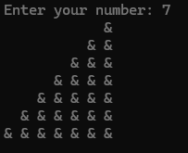 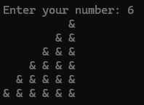**

**Program27: Write a C program using switch case with following options.  
1. Area of a Square**

**2. Area of a Rectangle**

**3. Area of a Triangle.**

**Depending upon user selection perform necessary action using function calls for each case**

**Solution:**

#include<stdio.h>

void main(){

int ch;

float a,l,b,base,height;

void area_of_square(float);

void area_of_rectangle(float,float);

void area_of_triangle(float,float);

printf("Enter your choice\n1. Area of a square\n2. Area of a rectangle\n3. Area of a triangle\n");

scanf("%d",&ch);

switch(ch){

case 1:

printf("Enter length of side of square: ");

scanf("%f",&a);

area_of_square(a);

break;

case 2:

printf("Enter length and breadth of the rectangle: ");

scanf("%f %f",&l,&b);

area_of_rectangle(l,b);

break;

case 3:

printf("Enter length of base and height of the triangle: ");

scanf("%f %f",&base,&height);

area_of_triangle(base,height);

break;

default:

printf("Invalid option\n");

}

}

void area_of_square(float a){

float result = a*a;

printf("The area of given square is %.2f\n",result);

}

void area_of_rectangle(float l, float b){

float result = l * b;

printf("The area of given rectangle is %.2f\n",result);

}

void area_of_triangle(float b,float h){

float result = 0.5*(b*h);

printf("The area of given triangle is %.2f\n",result);

}

**Output test cases:  
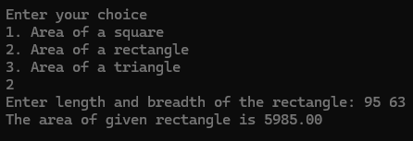**

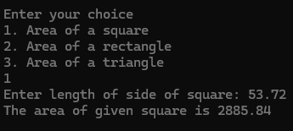

**Program28: Write a C program to swap two character values using pass by reference method such that**

**before swapping Char1 = ‘S’ Char2 = ‘R’  
After swapping Char1 = ‘R’ and Char2 = ‘S’**

**Solution:**

#include<stdio.h>

void main(){

void swap(int *, int *);

char var1,var2;

int *p1,*p2;

printf("Enter first character: ");

scanf(" %c",&var1);

printf("Enter second character: ");

scanf(" %c",&var2);

p1 = &var1;

p2 = &var2;

printf("Before swap: %c %c\n",var1,var2);

swap(p1,p2);

}

void swap(int *p1, int *p2){

int temp;

temp = *p2;

*p2 = *p1;

*p1 = temp;

printf("After swap: %c %c",*p1,*p2);

}

**Output test cases:**

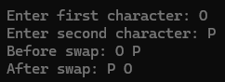 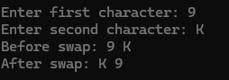

**Program29: Write a C program to print the following pattern**

**5**

**5 5 5**

**5 5 5 5 5**

**5 5 5 5 5 5 5**

**Solution:**

#include<stdio.h>

void main()

{

int n,i,j;

printf("Enter your number: ");

scanf("%d",&n);

for(i=1;i<=n;i++){

for(j=1;j<=2*i-1;j++){

printf("5 ");

}

printf("\n");

}

}

**Output test cases:**

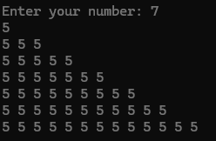 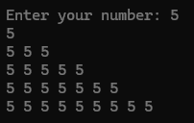

**Program30: Write a program using switch case. Display a menu using 4 cases.  
1. Addition  
2. Subtraction  
3. Multiplication  
4. Division  
5. Exit  
Depending upon the user selection perform particular action on two integers.   
(Run a while loop, until you select option 5, the program must be running)  
NOTE : To exit from a program you can give exit(0);**

**Solution:**

#include<stdio.h>

void main(){

int ch,a,b;

start:

printf("Enter two numbers: ");

scanf("%d %d",&a,&b);

printf("Enter your choice\n1. Addition\n2. Subtraction\n3. Multiplication\n4. Division\n5. Exit\n");

scanf("%d",&ch);

switch(ch){

case 1:

printf("Addition: %d\n\n",a+b);

goto start;

break;

case 2:

printf("Subtraction: %d\n\n",a-b);

goto start;

break;

case 3:

printf("Multiplication: %d\n\n",a*b);

goto start;

break;

case 4:

printf("Division: %d\n\n",a/b);

goto start;

break;

case 5:

printf("Exited.\nProgram has ended.\n");

break;

default:

printf("Invalid option\n");

break;

}

}

**Output test cases:**

